**D & J Tech Solutions**

**Meeting Minutes**

**30/6/20**

* Team met to discuss project ideas.
* Came to the conclusion of an inventory and staff management application for a small food service business.
* Rough draft wireframes, database tables and context diagrams were brainstormed. (attached)
* Microsoft teams will be our main communication tool.
* Team created Project created on github. Started adding items to Kanban board
* Joel will begin requirements/system design docs
* Dan will create project folder and repository on github.

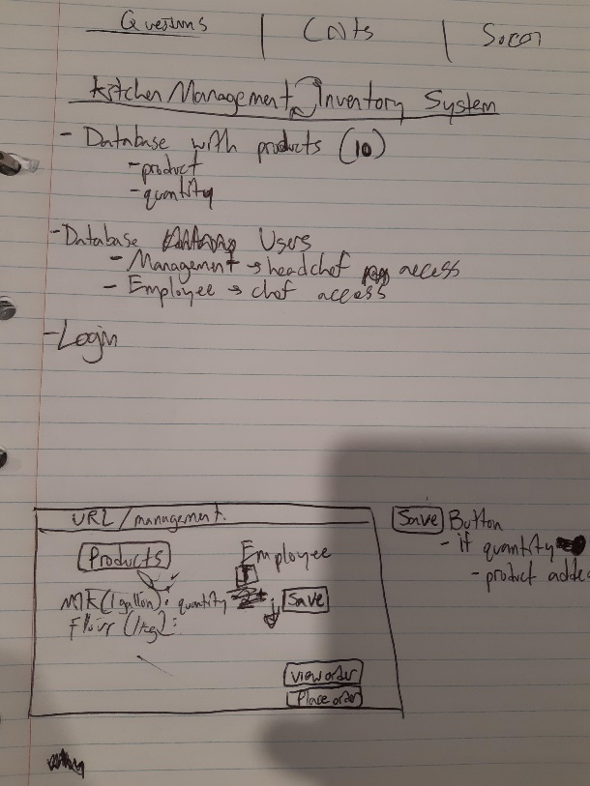 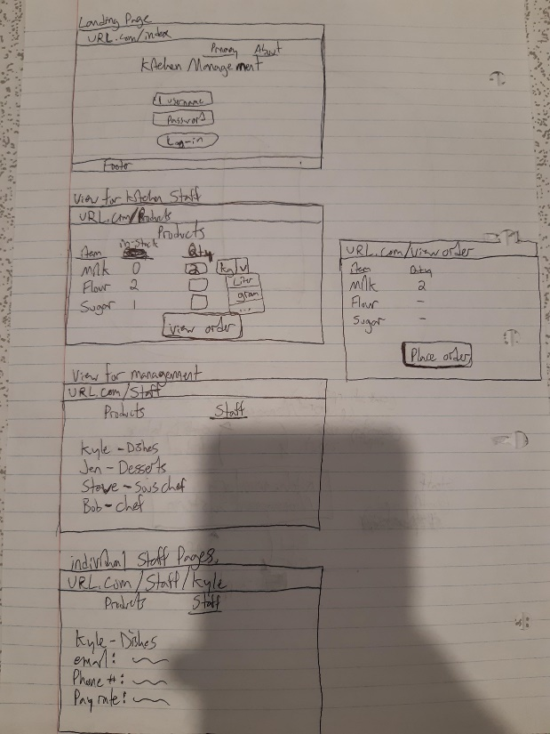

**7/7/20**

* Discussed Github desktop and its version control capabilities.
* Dan demonstrated Github desktop with team.
* Reviewed progress of team member tasks.

**9/7/20 – Microsoft Teams video call**

* Discussed populating the database via the admin account.
* Login details text file created for log in instructions.
* Removed Usage entity from database

**10/7/20 – Microsoft Teams video call**

* Changed design of employee page. Modal will pop up displaying individual employee information rather than a template when an employee is selected.
* Fix missing information (phone number, email) in ERD, model, view, html for the employee entity.

**11/7/20 – Microsoft Teams video call**

* Employee page will be added back into the project
* Admin hyperlink needed in navbar
* User accounts added
* Testing of account privileges – worked as intended.